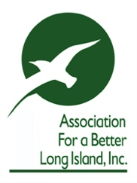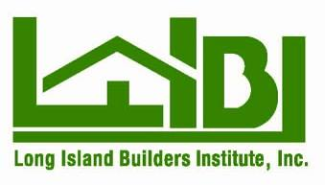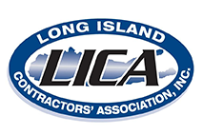

Testimony before the Metropolitan Transportation Authority on MTA’s federal grant proposals for Federal Fiscal Year 2022

Delivered electronically on February 8, 2022

On behalf of the Association for a Better Long Island, Long Island Association, Long Island Builders Institute, Long Island Contractors Association and the Hauppauge Industrial Association, organizations representing the region’s leading business and economic development communities, we write in support of the Metropolitan Transportation Authority’s (“MTA”) request for federal assistance for its Federal Fiscal Year 2022.

While federal funds are critical to improving and maintaining our rail system, we are again surprised and disappointed that the MTA has not included on its list of projects to be requested the electrification of the Long Island Rail Road (“LIRR”) main line from Ronkonkoma to Yaphank and the relocation of the Yaphank LIRR station.

As you are aware, we previously sent a letter on August 30, 2021 to Mr. Janno Lieber, Chair and CEO, to formally request that these projects be included within the MTA Capital Plan as soon as possible. Subsequent to that letter, the County of Suffolk and the Town of Brookhaven sent a letter to Mr. Lieber informing the MTA that both municipalities have reached an agreement regarding the new site for the relocated Yaphank LIRR station and urged construction to begin as soon as possible.

The inclusion of these two projects within the application for federal funds allows the project to move forward immediately. The feasibility studies for these projects were completed in part with the $20 million in state funds previously allocated. The MTA can now utilize the balance of this funding, combined with the new federal funding, to proceed with the electrification and the relocation of the Yaphank LIRR station. The relocation of the Yaphank LIRR station and the electrification of the line will support our regional economy by:

- Increasing access to Brookhaven National Lab, which generates hundreds of millions of dollars of economic output for New York State and employs 2,500 people with more than 5,000 visitors annually. BNL recently won a contract from the US Department of Energy of up to 2.6 billion to construct a new Electron Ion Collider to study nuclear physics and thus a direct route from NYC to BNL is needed immediately and will become even more important in the years ahead;
- Increasing ridership on the LIRR and addressing issues including parking and traffic with other crowded stations and the roads leading to it, including the Ronkonkoma station;
- Stimulating economic development in the Town of Brookhaven and along the William Floyd corridor. Future development and redevelopment on Long Island should be near transit hubs and a new station location presents a unique opportunity to engage the community, government officials and developers in a discussion about transit-oriented development.

On behalf of the Association for a Better Long Island, Long Island Association, Long Island Builders Institute, Long Island Contractors Association, and the Hauppauge Industrial Association, representing key entities that power our region’s economy, we urge the MTA to include the electrification of the Long Island Rail Road (“LIRR”) Main Line from Ronkonkoma to Yaphank and the relocation of the Yaphank LIRR station on its list of projects being requested. By doing so the MTA has the means of strengthening the bi-county region’s mass transit future.

Sincerely,

Association for a Better Long Island

Long Island Association

Long Island Builders Institute

Long Island Contractors Association

